The change in analytics, AI, ML and automation technologies has been rapid and broad. There’s no doubt that the current array of technologies is more powerful and less expensive than the previous generation. It enables companies to store and analyze both far more data and many different types of it. Analyses and recommendations come much faster, approaching real time in many cases. In short, all analytical boats have sailed.

The last decade, of course, was the era of data driven artificial intelligence. New data sources such as online clickstreams required a variety of new hardware offerings on premise and in the cloud, primarily involving distributed computing — spreading analytical calculations across multiple commodity servers — or specialized data appliances. Such machines often analyze data “in memory,” which can dramatically accelerate times-to-answer. Cloud-based analytics made it possible for organizations to acquire massive amounts of computing power for short periods at low cost. Even small businesses could get in on the act, and big companies began using these tools not just for big data but also for traditional small, structured data.

Along with the hardware advances, the need to store and process big data in new ways led to a whole constellation of open source software, such as Hadoop and scripting languages. Hadoop is used to store and do basic processing on big data, and it’s typically more than an order of magnitude cheaper than a data warehouse for similar volumes of data. Today many organizations are employing Hadoop-based data lakes to store different types of data in their original formats until they need to be structured and analyzed.

There are many business outcomes targeted with improving data and analytics, to name a few:

Proactivity & Anticipating Needs: Organisations are increasingly under competitive pressure to not only acquire customers but also understand their customers’ needs to be able to optimise customer experience and develop long standing relationships. By sharing their data and allowing relaxed privacy in its use, customers expect companies to know them, form relevant interactions, and provide a seamless experience across all touch points. Additionally, customers expect and companies need to deliver contextually relevant, real-time experiences.

## Mitigating Risk & Fraud: Security and fraud analytics aims to protect all physical, financial and intellectual assets from misuse by internal and external threats. Efficient data and analytics capabilities will deliver optimum levels of fraud prevention and overall organisational security: deterrence requires mechanisms that allow companies to quickly detect potentially fraudulent activity and anticipate future activity, as well as identifying and tracking perpetrators. Furthermore, integration and correlation of data across the enterprise can offer a unified view of the fraud across various lines of business, products, and transactions.

## Delivering Relevant Products: Products are the life-blood of any organisation and often the largest investment companies make. The product management team’s role is to recognise trends that drive strategic roadmap for innovation, new features, and services. Effective data collation from 3rd party sources where individuals publicise their thoughts and opinions, combined with analytics will help companies stay competitive when demand changes or new technology is developed as well as facilitate anticipation of what the market demands to provide the product before it is requested.

## Personalisation & Service: Companies are still struggling with structured data, and need to be extremely responsive to cope with the volatility created by customers engaging via digital technologies today. Being able to react in real time and make the customer feel personally valued is only possible through advanced analytics. Big data offers the opportunity for interactions to be based on the personality of the customer, by understanding their attitudes and considering factors such as real-time location to help deliver personalisation in a multi-channel service environment.

## Optimizing & Improving the Customer Experience: Advanced analytical techniques can be deployed to improve field operations productivity and efficiency as well as optimize an organisational workforce according to business needs and customer demand. Optimum utilisation of data and analytics will also ensure that continuous improvements are instigated on an on-going basis as a result of end-to-end view and measurement of key operational metrics. For example, many organisations, inventory is the largest item in the current assets category - too much or not enough inventory can directly affect a company’s direct costs and profitability. Data and analytics can support inventory management by providing uninterrupted production, sales, and/or customer-service levels at minimum cost. The use of data and analytics can provide transparency into current and planned inventory positions as well as deliver insight into drivers of height, composition and location of stock and aid the determination of inventory strategy and decision making. Customers expect a relevant, seamless experience and for companies to know them wherever they engage.

The potential for AI to drive revenue and profit growth is enormous. Marketing, customer service, and sales were identified as the top three functions where AI can realize its full potential according to a survey of 1,093 executives by Forbes. Sales organizations are dramatically improving sales performance by using algorithms to help with the basics of account and lead prioritization and qualification, recommending the content or sales action that will lead to success, and reallocating sales resources to the places they can have the most impact. Marketers are looking for AI to fuel enormous efficiencies by targeting and optimizing the impact of huge investments in media, content, products, and digital channels. And in customer service, AI is opening entire new frontiers in customer experience and success by applying NLP, sentiment analysis, automation, and personalization to customer relationship management. 90% of organizations are using AI to improve their customer journeys, revolutionize how they interact with customers and deliver them more compelling experiences.

Executives who allocate capital and the managers who will lead the AI transformation cannot afford to have a poor understanding of something so fundamental to business and the creation of value today. The great fear about cognitive technologies is that they will put masses of people out of work. Of course, some job loss is likely as smart machines take over certain tasks traditionally done by humans. However, we believe that most workers have little to fear at this point. Cognitive systems perform tasks, not entire jobs. The human job losses we’ve seen were primarily due to attrition of workers who were not replaced or through automation of outsourced work. Most cognitive tasks currently being performed augment human activity, perform a narrow task within a much broader job, or do work that wasn’t done by humans in the first place, such as big-data analytics.

To conclude, as intelligent machines and software are integrated more deeply into the workplace, workflows and workspaces will continue to evolve to enable humans and machines to work together. As self-checkout machines are introduced in stores, for example, cashiers can become checkout assistance helpers, who can help answer questions or troubleshoot the machines. More system-level solutions will prompt rethinking of the entire workflow and workspace. Warehouse design may change significantly as some portions are designed to accommodate primarily robots and others to facilitate safe human-machine interaction. Workplaces and workflows will change as more people work alongside machines.

References :

<https://towardsdatascience.com/using-analytics-for-better-decision-making-ce4f92c4a025>

<https://www.mckinsey.com/~/media/mckinsey/business%20functions/mckinsey%20analytics/our%20insights/the%20age%20of%20analytics%20competing%20in%20a%20data%20driven%20world/mgi-the-age-of-analytics-full-report.ashx>

<https://www.digitalvidya.com/blog/reasons-data-analytics-important/>

<https://www.entrepreneur.com/article/341782>

<https://hbr.org/2017/06/how-analytics-has-changed-in-the-last-10-years-and-how-its-stayed-the-same>

<https://www.mckinsey.com/business-functions/mckinsey-analytics/our-insights/catch-them-if-you-can-how-leaders-in-data-and-analytics-have-pulled-ahead#interactive>

<https://www.sas.com/en_us/insights/analytics/big-data-analytics.html>

<https://aibusiness.com/the-ai-summit-industry-insights-report-2020/>

<https://sloanreview.mit.edu/projects/winning-with-ai/>

<https://www.teradata.com/Blogs/5-Big-Benefits-of-Data-and-Analytics-for-Positive-Business-Outcomes>

<https://www.forbes.com/sites/louiscolumbus/2018/04/22/the-state-of-digital-business-transformation-2018/#62a6f0875883>

<https://trainingindustry.com/magazine/jul-aug-2019/leveraging-learning-analytics-to-improve-business-outcomes-where-to-start/>

Appendix:

Key takeaways from the study include the following:

* **89% of enterprises have plans to adopt or have already adopted a digital-first business strategy with Services (95%), Financial Services (93%) and Healthcare (92%) leading all industries.** Education, high-tech, manufacturing, retail, and government are also quickly adopting digital-first strategies to improve process efficiencies and meet and exceed customer expectations.

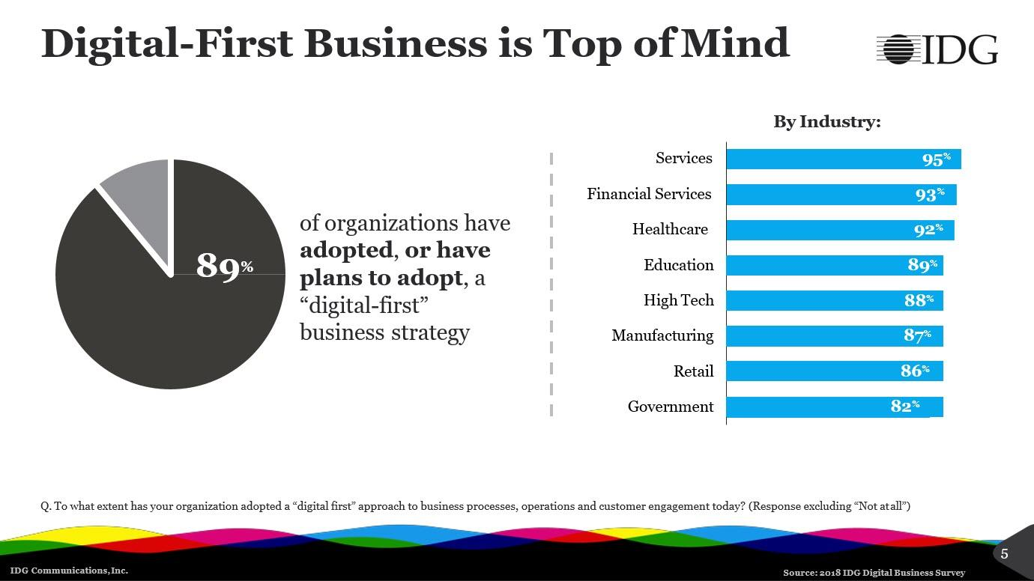

**Big Data/Analytics (58%), mobile technologies (59%), private cloud (53%), public cloud (45%) and APIs and embeddable technologies (40%) are the top five technologies already implemented.** Additional technologies currently in production include Application Performance Monitoring (APM) (18%), microservices and containers (15%), Software-defined storage (SDS) (14%) and Software-defined networking (SDN) (14%). Artificial Intelligence (39%), machine learning (34%), and the Internet of Things (31%) are the top three technologies enterprises are researching today.

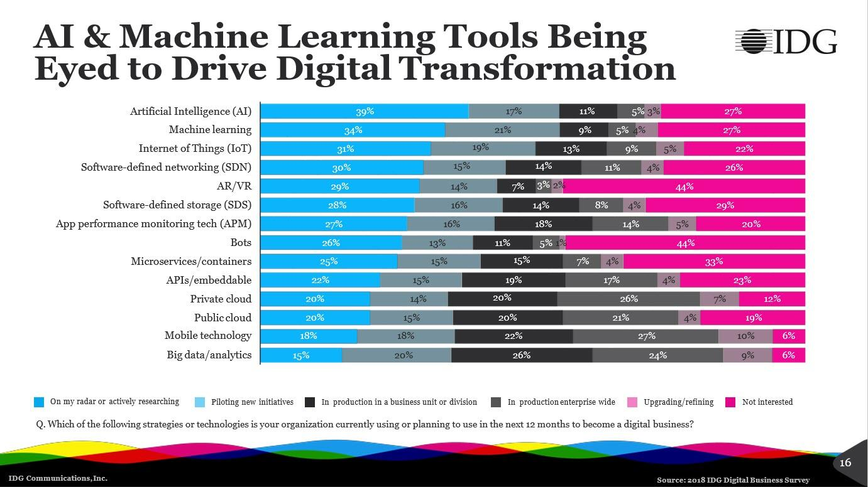

**Big Data/Analytics, mobile technologies, and private cloud contribute most to an organization’s revenue growth.** IDG analyzed which technologies are contributing most and least or revenue growth. With 49% of enterprises saying excelling at managing business performance through data availability and visibility is what defines their digital business, it’s understandable why Big Data/Analytics is perceived by 70% of IT executives as contributing to revenue growth.

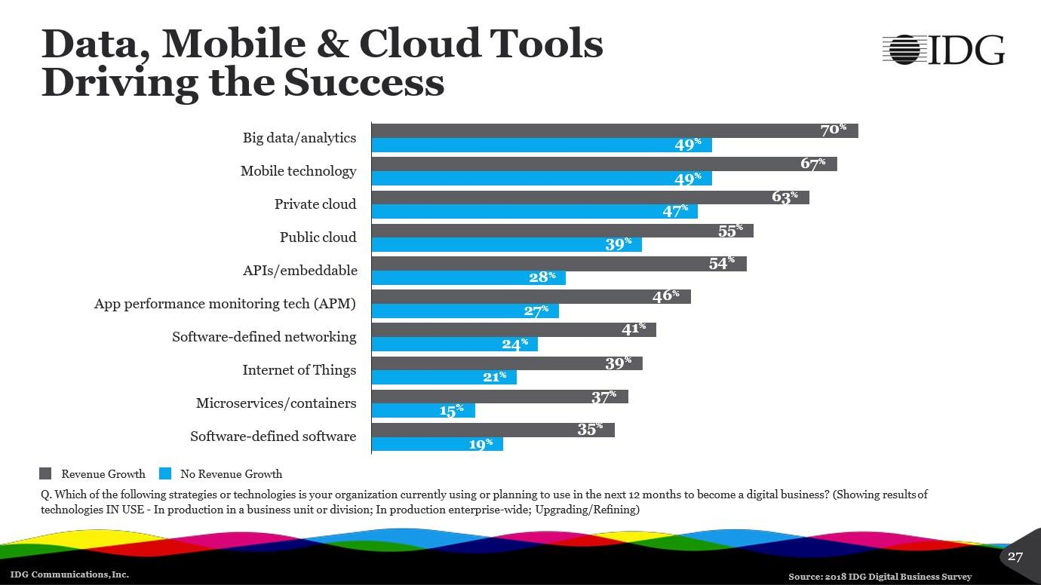

**61% of enterprises say IoT plays a role in their digital business strategies with manufacturing and high-tech leading all other industries.** Just 39% of small & medium businesses (SMBs) say IoT plays a role in their digital business strategies today. Finance and government industries are the least likely to adopt IoT as part of their digital business strategies due to legacy systems being very difficult to change or integrate with and security concerns.

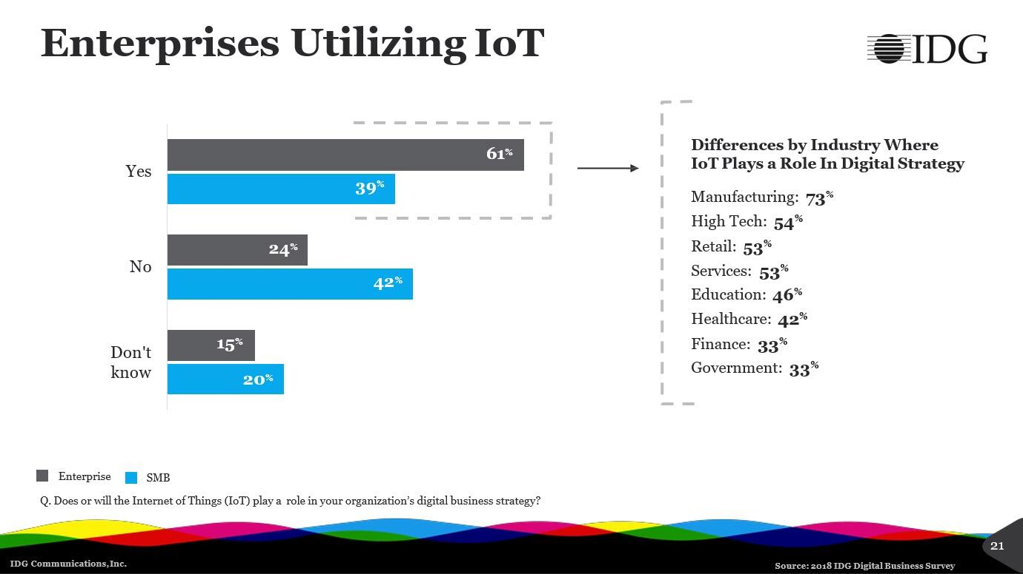

**73% of manufacturing executives or IT decision makers (ITDM) says IoT plays a role in their digital business strategy, with 69% saying IoT is used to monitor equipment and machinery today.** 24% of manufacturing IT executives interviewed say IoT is in production in a business unit or division. Creating a business case in manufacturing for IoT begins by looking at how quality, time-to-market and production performance can be improved. The manufacturing metric [Overall Equipment Effectiveness (OEE)](https://www.oee.com/calculating-oee.html) is one of the primary catalysts driving real-time monitoring including IoT adoption across manufacturing today.

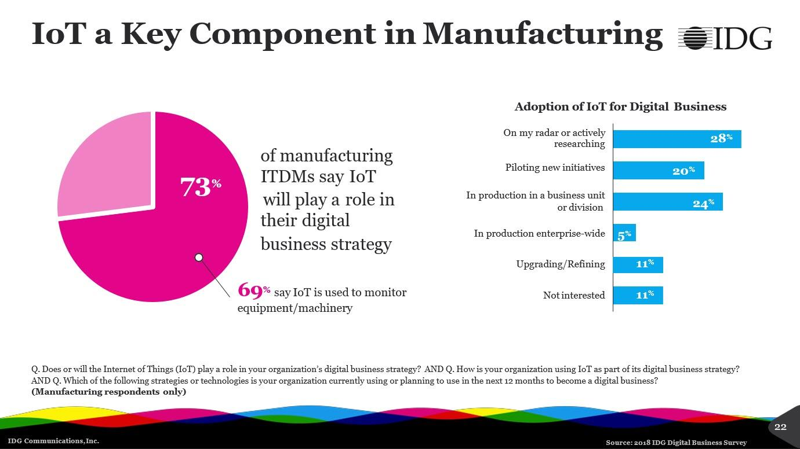

**Start-ups can increase revenue by 34% relying on digital-first strategies, with all enterprises increasing revenue by 23% with new product and service offerings being the largest contributor to revenue growth across all companies.** 30% of all enterprises interviewed by IDG say that new product and service offerings are the primary sources of revenue growth for their companies, followed by adding new capabilities inside the company and improving sales capacity to cross-sell and upsell. 22% say that their improved ability to integrate and analyze company, customer and external data is contributing to increased revenue. 22% also credit digital business strategies with the ability to increase product and service delivery speeds. New partnerships, global or regional expansion and M&A (merger & acquisition) activity are the remaining factors driving revenue growth. Multiple responses were allowed to the original survey.

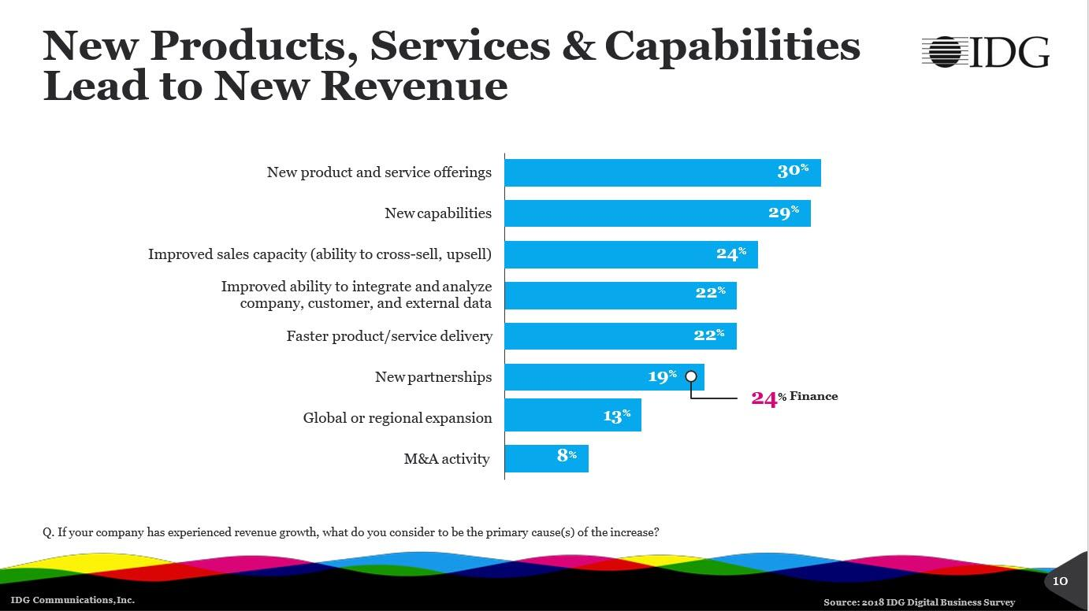

**Enterprises’ definition of a digital business varies from enabling worker productivity to meeting customer experiences.** 52% of enterprises say enabling worker productivity through tools such as mobile, data access, and AI-assisted processes are the essence of their digital business strategy. 49% say better managing business performance through data availability, and visibility is what defines their digital business, and 46% say meeting customer experience expectations using digital technologies is the center of their digital business.

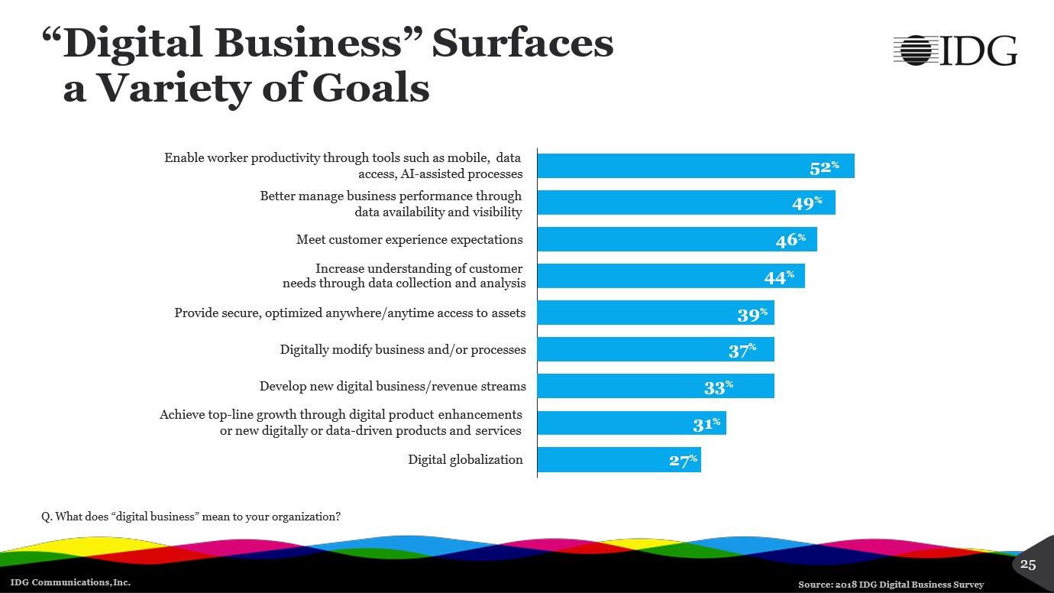

**62% say delivering an excellent customer experience as measured by customer satisfaction scores defines success as a digital-first business.** The intensity to gain high customer satisfaction scores in retail is high, with 79% saying this is by far their most important benchmark of a successful digital-first business. 70% of manufacturers define the digital-first business strategies as successful when they improve process efficiency through automation. 53% of services companies and 51% of finance companies define digital-first business success by their ability to accelerate time-to-market.

